JD Anki Glass Card Style System
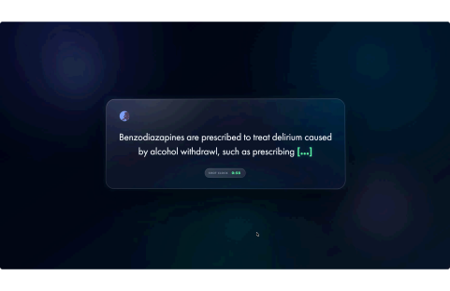
Overview, Capabilities, and Reference Deck Instructions
This document describes the current standalone JD Anki Glass Card System: a custom Anki card environment built for medical school review, peer-facing study materials, and future integration with Noctyrium.
The system is currently separate from Noctyrium, but it is designed to connect into the Noctyrium workflow later. The long-term goal is for Noctyrium to help load source material, identify lecture/ module context, route cards into the correct decks, and eventually generate cards directly from lecture slides, screenshots, notes, and indexed course folders.
The current build proves the core concept: high-quality Anki cards can be generated and reviewed inside a polished, recognizable, reusable visual system without losing Anki’s normal scheduling behavior, media support, answer reveal logic, or review controls.
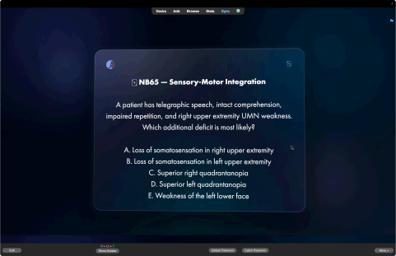1
Current Working Card Types
The current system includes two working custom card formats:
Basic Glass Card
Cloze Glass Card
The Basic format is built for question-and-answer review. It is useful for clinical stems, PQ-style questions, multiple-choice prompts, lecture-derived explanations, short-answer testing, and high-yield reasoning cards.
The Cloze format is built for active recall. It is useful for diagnostic criteria, mechanisms, drug facts, symptom clusters, pathway steps, definitions, lecture facts, image-supported concepts, and compressed exam material.
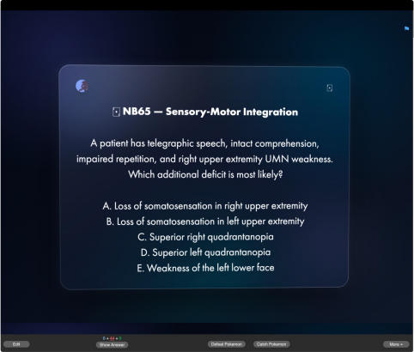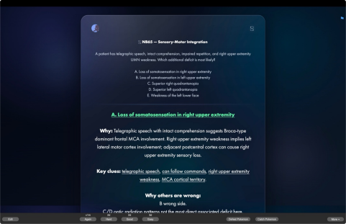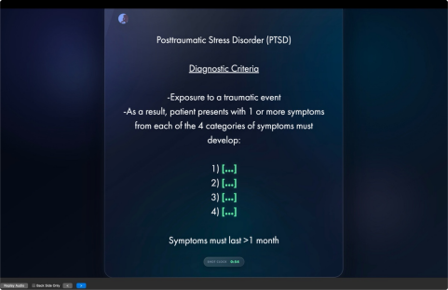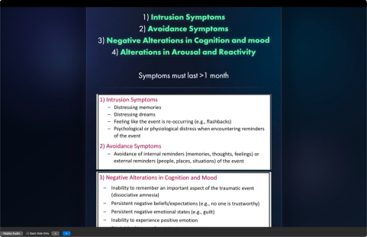2
Capability Overview
The current card system supports a full visual and functional review experience inside Anki.
It supports custom front and back templates, custom CSS, embedded media, responsive layouts, animated card entry, soft glassmorphic panels, ambient background orbs, animated border luster, cursor-reactive card depth, mobile-safe fallback behavior, and accessible reduced-motion handling.
The Basic card can present a complete clinical question on the front, then reveal the answer, explanation, and reasoning on the back while preserving the original prompt above the answer. This makes it well-suited for peer-shared question cards because the reviewer does not lose the context after revealing the answer.
The Cloze card can hide key terms or concepts inside a larger explanation, reveal them cleanly, and display extra supporting material below. It also includes a visible “Shot Clock” timer on the front side, making it useful for timed recall and fast pass/fail review.
The design supports both text-heavy and image-heavy cards. Lecture screenshots, diagrams, tables, and visual explanations can be placed directly into the card fields and rendered inside the same glass interface.
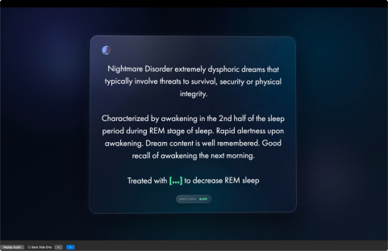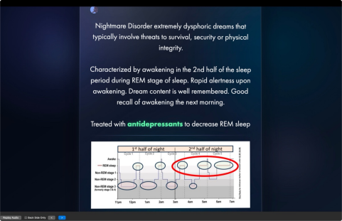3
Why the System Is Useful
This card system is not only a visual skin. It creates a consistent review environment for AI-assisted medical studying.
The same card structure can hold a single fact, a full question stem, a differential diagnosis clue set, an image-based teaching point, or a lecture-slide-derived explanation. That makes it reusable across course modules, board-style practice, custom peer decks, and Noctyrium-generated study outputs.
The card styling is also distinctive. The ������������ visual identity, dark glass interface, green reveal states, and animated review surface make the cards feel intentionally designed and recognizable. That matters because these cards are meant to be shared, demonstrated, and used repeatedly by peers.
[INSERT SCREENSHOT: ������������ deck/card identity]
The current deck was made using AI-assisted generation, custom HTML/CSS templates, and Anki’s native note type system. It demonstrates that custom medical cards can be generated with a repeatable structure rather than manually formatted one at a time.
4
Reference Deck File: Test.apkg
The included file is:
Test.apkg
This file contains a single reference card. It is not meant to be a full deck. It is meant to preserve the working card type, media behavior, styling, and code structure so another user can import it, inspect it, and use it as a starting point.
After downloading Test.apkg, open it with Anki. Anki should import the deck/card into the current profile.
Once imported, the recommended workflow is to keep the card as a reference rather than immediately mixing it into an active study deck. It can be suspended, moved into a dedicated reference deck, or kept in a separate holding deck.
Suggested handling:
Download Test.apkg.
Open it with Anki.
Import the deck.
Find the imported card in Browse.
Suspend the card if you do not want it appearing in reviews.
Move it into a reference deck or keep it in place as a template source.
Use it to inspect the card type, media, fields, front template, back template, and styling.
The reason to keep it rather than delete it is that the file demonstrates proper media loading and working template behavior. If the card is deleted before the note type and media are inspected, the user may lose the easiest working reference for rebuilding the style.
5
Included Code Structure
The system should be distributed as separate documents rather than one combined code block. Recommended file/document layout:
Basic Front Template
Basic Back Template
Basic CSS
Cloze Front Template
Cloze Back Template
Cloze CSS
README Setup Instructions
Test.apkg reference deck
This keeps the system easier to install, audit, modify, and share.
The README should explain that the imported .apkg provides a working example, while the separate template documents provide the editable source code for rebuilding or modifying the card type.
6
Noctyrium Integration Direction
This card system is intended to become part of a larger Noctyrium pipeline.
The future direction is for Noctyrium to automatically load indexed lecture material, detect course/ module context, create or suggest Anki cards, apply the correct card style, attach screenshots or slide derived media, and route cards into the correct deck or tag structure.
Possible future capabilities include:
Automatic lecture-slide-to-card conversion.
AI-generated Basic cards from lecture objectives or PQs.
AI-generated Cloze cards from high-yield facts.
Automatic tagging by course, term, module, lecture, and topic.
Automatic media attachment from lecture screenshots.
Deck generation from selected course folders.
Question-maker workflows for board-style prompts.
Image Occlusion card style expansion.
Reverse card support.
Peer-shareable template packs.
The current system is the visual and technical foundation for that workflow. It already shows that the card style can support custom medical content, AI-generated explanations, images, and polished review behavior. The next step is automation: making Noctyrium able to prepare and load these cards with less manual setup.
7
Build State Summary
The current build is functional as a standalone Anki card template system.
It has working Basic and Cloze formats, working media support, polished glass styling, animated review behavior, and a single-card .apkg reference file for testing and distribution.
It is not yet a full automated Noctyrium card-generation system. That is the future direction. The current state is the proof-of-concept and template layer: the card environment that future automation will generate into.
In practical terms, this is ready to show as a working card style, a peer-facing teaser, and a technical foundation for future AI-assisted medical deck generation.
8

